Parent and Toddler Sessions and Childcare

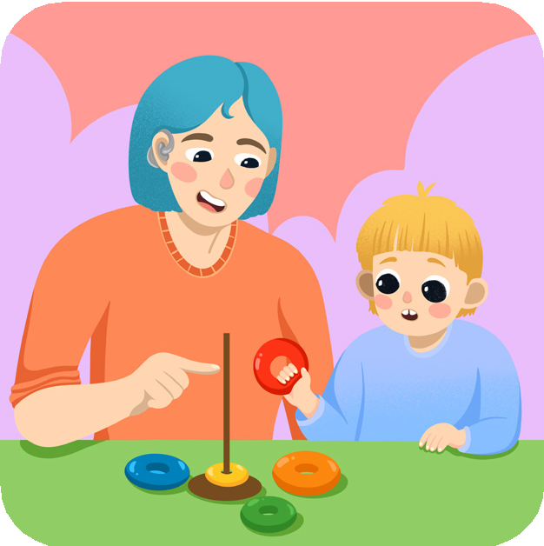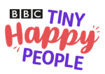

# Going to Parent and Toddler sessions and Nursery:

Going to parent and toddler sessions or childcare can be really helpful for your child’s speech, language and communication development. They will have the opportunity to meet other children of a similar age, practice their listening and turn taking skills; play with a range of different toys and hear language from you, other adults and their peers.

# Local Parent and Toddler Sessions

Your child could be eligible for free childcare from a playgroup; day nursery; nursery schools or some childminders.

Follow the link below to find out if you are eligible.

[Free childcare for two year olds | Newcastle City Council](https://www.newcastle.gov.uk/services/schools-learning-and-childcare/childcare-and-early-years/free-early-education-and-0) **QR**

Follow the link below to find a list of local playgroups and nurseries

Local playgroups **QR**

and nurseries

**Edit this text for your local setting**